Notes : this is not working in virtualbox

- Install ubuntu & Update using Update Manager
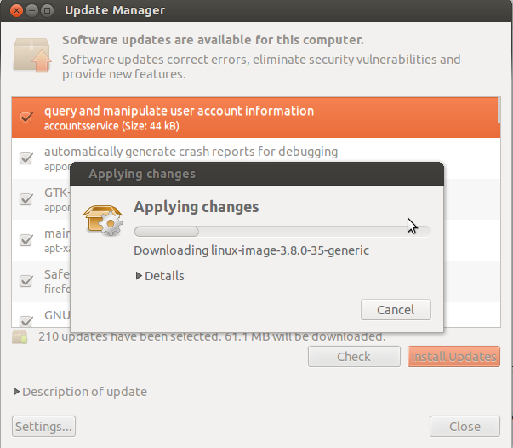

- Install ROS, Open terminal, and run the following commands :
  - sudo sh -c 'echo "deb http://packages.ros.org/ros/ubuntu precise main" > /etc/apt/sources.list.d/ros-latest.list'

  - wget http://packages.ros.org/ros.key -O - | sudo apt-key add -
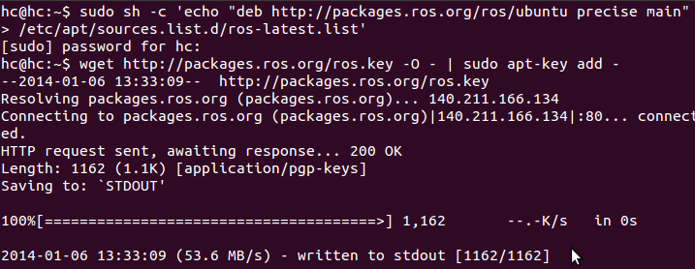

  - sudo apt-get update
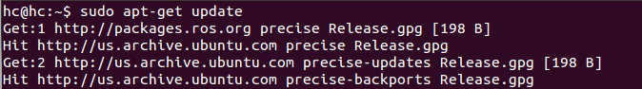

  - sudo apt-get install ros-hydro-desktop-full
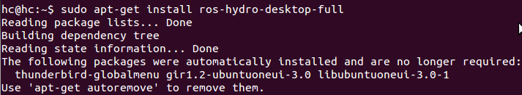

If you are prompted Do you want to continue, put "Y"

If you are prompted if it should start the hddtemp daemon, choose "<No>"
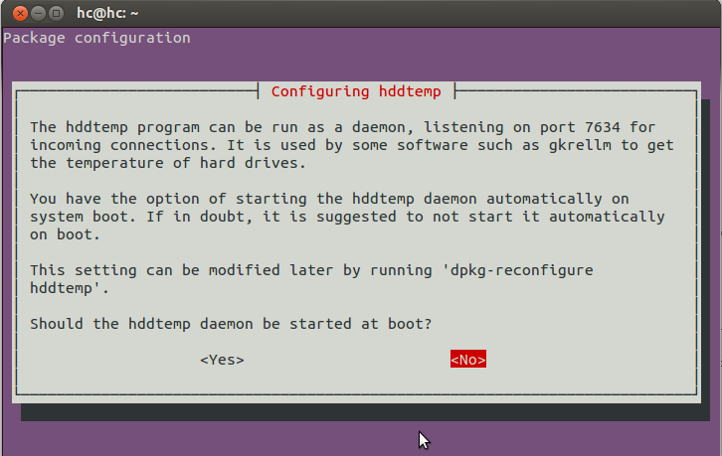

  - apt-cache search ros-hydro

  - sudo rosdep init
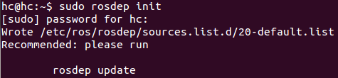

  - rosdep update
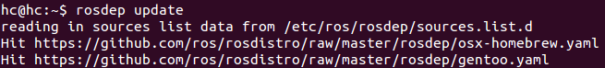

  - echo "source /opt/ros/hydro/setup.bash" >> ~/.bashrc
source ~/.bashrc
  - sudo apt-get install python-rosinstall
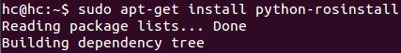

If you are prompted Do you want to continue, put "Y"

  - sudo apt-get install ros-hydro-ros-tutorials
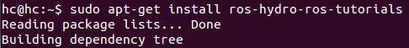

- Install kinect drivers, Open terminal, and run the following commands :
  - (Install the openni driver)
sudo apt-get install ros-hydro-openni-camera ros-hydro-openni-launch ros-hydro-openni-tracker

If you are prompted Do you want to continue, put "Y"

  - (Install the primesense and sensor kinect dependencies)
sudo apt-get install git-core cmake freeglut3-dev pkg-config build-essential libxmu-dev libxi-dev libusb-1.0-0-dev doxygen graphviz mono-complete
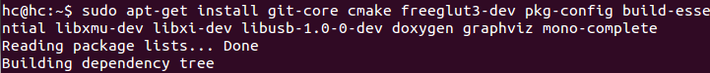

  - (Download the SensorKinect driver)
mkdir ~/kinect
cd ~/kinect
git clone git://github.com/avin2/SensorKinect.git
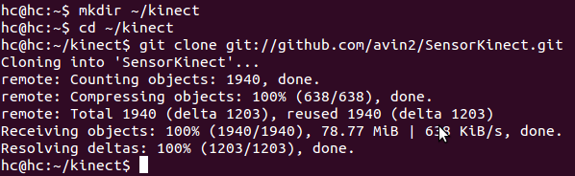

  - (Create the redist of SensorKinect)
cd ~/kinect/SensorKinect/Platform/Linux/CreateRedist/
./RedistMaker
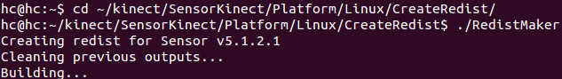

  - (Install the SensorKinect driver)
cd ~/kinect/SensorKinect/Platform/Linux/Redist/Sensor-Bin-Linux-x86-v5.1.2.1
sudo ./install.sh
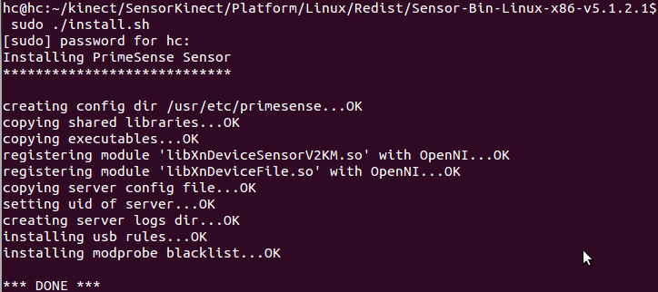

  - try connecting the kinect through usb port
  - check the connection by command “lsusb”. It should has devices named “Microsoft Corp.”
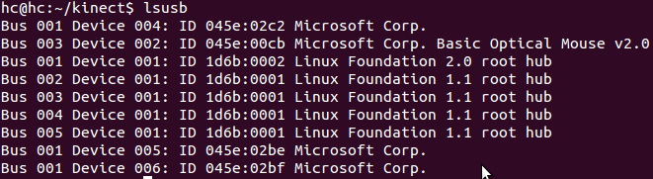

  - (try running the connection)
roslaunch openni_launch openni.launch
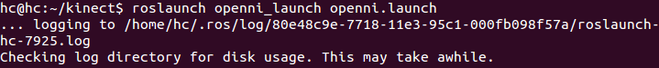
It should say that 1 device is connected.
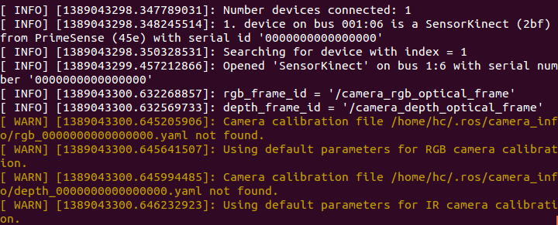

To view the camera, on another terminal, run
rosrun image_view image_view image:=/camera/rgb/image_color

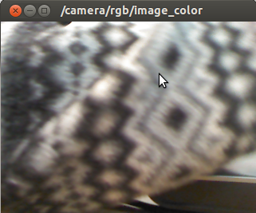

It should run image_view of the current camera. For more information you can run rostopic list, rosnode list, etc

  - (downloading the nite for openni_tracker driver)
cd ~/kinect/
wget http://www.openni.org/wp-content/uploads/2012/12/NITE-Bin-Linux-x86-v1.5.2.21.tar.zip
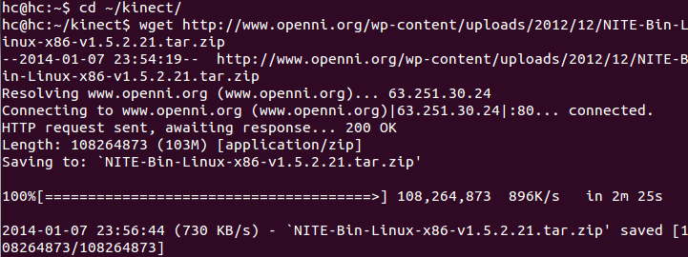

  - Unzip the file
unzip NITE-Bin-Linux-x86-v1.5.2.21.tar.zip
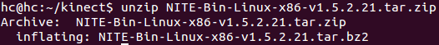

  - (extracting the files) go back to terminal,
cd ~/kinect
tar -xvjpf NITE-Bin-Linux-x86-v1.5.2.21.tar.bz2
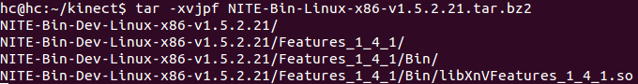

  - (run the install.sh in nite folder to install)
cd ~/kinect/NITE-Bin-Dev-Linux-x86-v1.5.2.21/
sudo ./install.sh
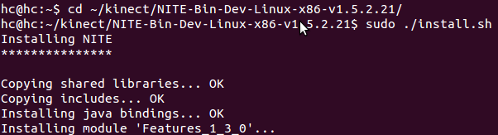

  - to test the tracker :
run roslaunch openni_launch openni.launch if you have not run it,
in the new terminal run the tracker
rosrun openni_tracker openni_tracker

in another terminal open the sampe file given by nite
cd ~/kinect/NITE-Bin-Dev-Linux-x86-v1.5.2.21/Samples/Bin/x86-Debug/
./Sample-Players
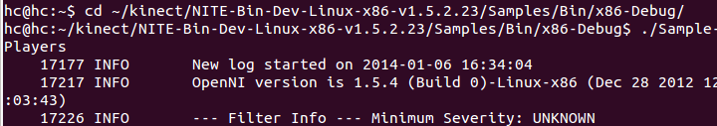

see if you are detected as user 1
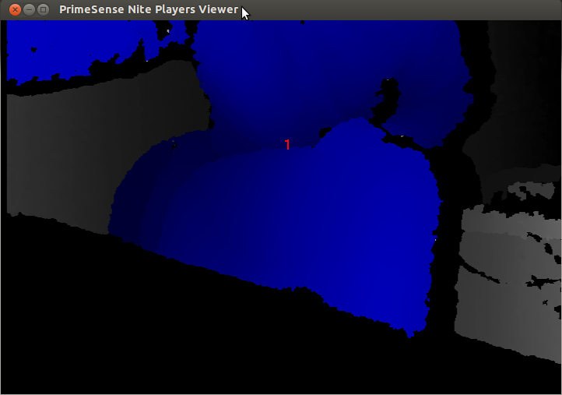

- Creating package, downloading and running the turtle_kinect program
  - If you haven't create your workspace, do this step, if you have, skip to step 3
source /opt/ros/hydro/setup.bash
mkdir -p ~/catkin_ws/src
cd ~/catkin_ws/src
catkin_init_workspace
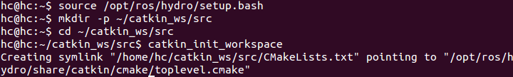

  - make the initial workspace folders
cd ~/catkin_ws
catkin_make
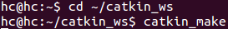

  - try connecting the kinect through usb port
  - check the connection by command “lsusb”. It should has 2 device named “Microsoft Corp.”

  - Download our project from github
cd ~/catkin_ws/src/
git clone https://github.com/vuhpham/turtle_kinect.git
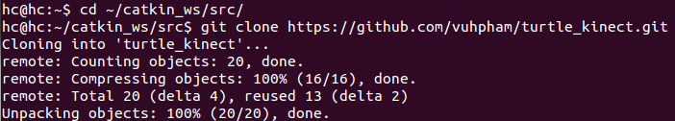

  - build the file
cd ~/catkin_ws/
catkin_make

  - to run the program :
source ~/catkin_ws/devel/setup.bash
roslaunch turtle_kinect start.launch

Have people standing up and check for movement. And move your right hand to make the turtle move
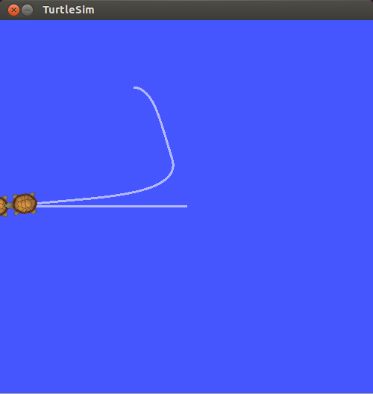

  - Finished

Thank you
~ Copyleft by Kinect Slayers :p~

